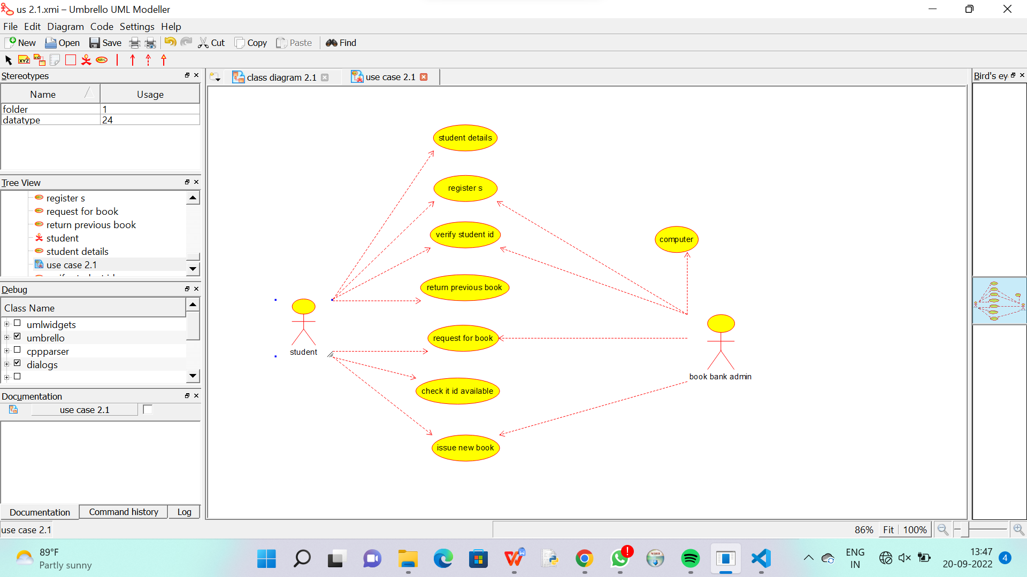

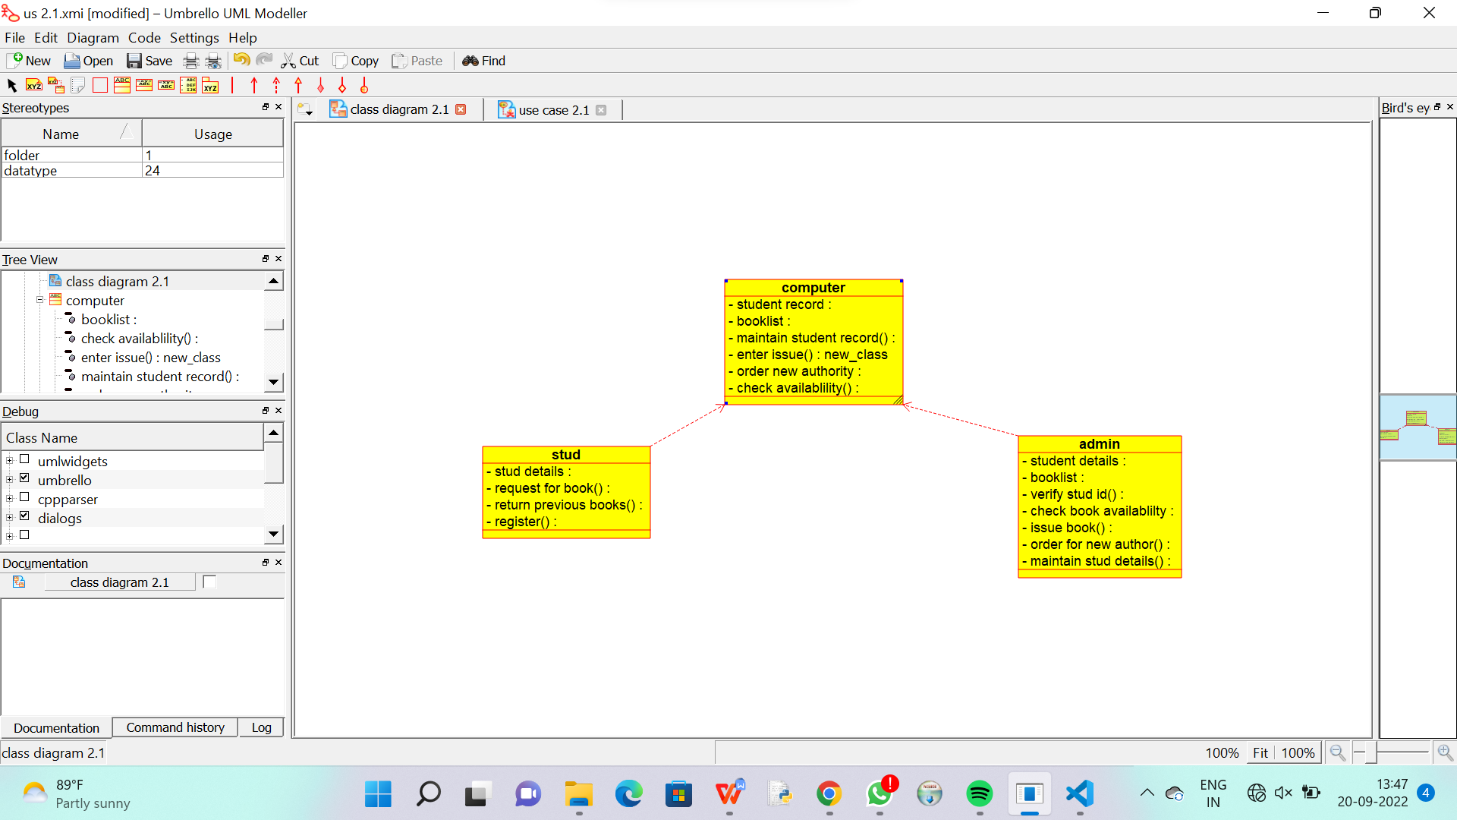

/**

 * Class stud

 */

public class stud {

  //

  // Fields

  //

  private void stud_details;

  private void request_for_book_;

  private void return_previous_books_;

  private void register_;

  //

  // Constructors

  //

  public stud () { };

  //

  // Methods

  //

  //

  // Accessor methods

  //

  /**

   * Set the value of stud_details

   * @param newVar the new value of stud_details

   */

  private void setStud_details (void newVar) {

    stud_details = newVar;

  }

  /**

   * Get the value of stud_details

   * @return the value of stud_details

   */

  private void getStud_details () {

    return stud_details;

  }

  /**

   * Set the value of request_for_book_

   * @param newVar the new value of request_for_book_

   */

  private void setRequest_for_book_ (void newVar) {

    request_for_book_ = newVar;

  }

  /**

   * Get the value of request_for_book_

   * @return the value of request_for_book_

   */

  private void getRequest_for_book_ () {

    return request_for_book_;

  }

  /**

   * Set the value of return_previous_books_

   * @param newVar the new value of return_previous_books_

   */

  private void setReturn_previous_books_ (void newVar) {

    return_previous_books_ = newVar;

  }

  /**

   * Get the value of return_previous_books_

   * @return the value of return_previous_books_

   */

  private void getReturn_previous_books_ () {

    return return_previous_books_;

  }

  /**

   * Set the value of register_

   * @param newVar the new value of register_

   */

  private void setRegister_ (void newVar) {

    register_ = newVar;

  }

  /**

   * Get the value of register_

   * @return the value of register_

   */

  private void getRegister_ () {

    return register_;

  }

  //

  // Other methods

  //

}

**

 * Class admin

 */

public class admin {

  //

  // Fields

  //

  private void student_details;

  private void booklist;

  private void verify_stud_id_;

  private void check_book_availablilty;

  private void issue_book_;

  private void order_for_new_author_;

  private void maintain_stud_details_;

  //

  // Constructors

  //

  public admin () { };

  //

  // Methods

  //

  //

  // Accessor methods

  //

  /**

   * Set the value of student_details

   * @param newVar the new value of student_details

   */

  private void setStudent_details (void newVar) {

    student_details = newVar;

  }

  /**

   * Get the value of student_details

   * @return the value of student_details

   */

  private void getStudent_details () {

    return student_details;

  }

  /**

   * Set the value of booklist

   * @param newVar the new value of booklist

   */

  private void setBooklist (void newVar) {

    booklist = newVar;

  }

  /**

   * Get the value of booklist

   * @return the value of booklist

   */

  private void getBooklist () {

    return booklist;

  }

  /**

   * Set the value of verify_stud_id_

   * @param newVar the new value of verify_stud_id_

   */

  private void setVerify_stud_id_ (void newVar) {

    verify_stud_id_ = newVar;

  }

  /**

   * Get the value of verify_stud_id_

   * @return the value of verify_stud_id_

   */

  private void getVerify_stud_id_ () {

    return verify_stud_id_;

  }

  /**

   * Set the value of check_book_availablilty

   * @param newVar the new value of check_book_availablilty

   */

  private void setCheck_book_availablilty (void newVar) {

    check_book_availablilty = newVar;

  }

  /**

   * Get the value of check_book_availablilty

   * @return the value of check_book_availablilty

   */

  private void getCheck_book_availablilty () {

    return check_book_availablilty;

  }

  /**

   * Set the value of issue_book_

   * @param newVar the new value of issue_book_

   */

  private void setIssue_book_ (void newVar) {

    issue_book_ = newVar;

  }

  /**

   * Get the value of issue_book_

   * @return the value of issue_book_

   */

  private void getIssue_book_ () {

    return issue_book_;

  }

  /**

   * Set the value of order_for_new_author_

   * @param newVar the new value of order_for_new_author_

   */

  private void setOrder_for_new_author_ (void newVar) {

    order_for_new_author_ = newVar;

  }

  /**

   * Get the value of order_for_new_author_

   * @return the value of order_for_new_author_

   */

  private void getOrder_for_new_author_ () {

    return order_for_new_author_;

  }

  /**

   * Set the value of maintain_stud_details_

   * @param newVar the new value of maintain_stud_details_

   */

  private void setMaintain_stud_details_ (void newVar) {

    maintain_stud_details_ = newVar;

  }

  /**

   * Get the value of maintain_stud_details_

   * @return the value of maintain_stud_details_

   */

  private void getMaintain_stud_details_ () {

    return maintain_stud_details_;

  }

  //

  // Other methods

  //

}